DIGITAL ELECTRONICS TEST -1
1. | Convert hexadecimal value 17 to decimal.
A. | 23₁₀ | B. | 16₁₀
C. | 10₁₀ | D. | 20₁₀

2. | Convert the following decimal number to 8-bit binary 178
A. | 10111011₂ | B. | 11011101₂
C. | 10110010₂ | D. | 10111100₂

5. | 3. Convert binary 1001110010 to hexadecimal.
A. | EE2₁₆ | B. | FF2₁₆
C. | 2FE₁₆ | D. | 272₁₆

 | 4. Convert the following binary number to decimal. 011111
A. | 11 | B. | 31
C. | 15 | D. | 10

Decode the following ASCII message.
1010011101010010101011000100101100101000001001000100000110100101000100
A. | STUDYHARD
B. | STUDY HARD
C. | stydyhard
D. | study hard

6. | Convert the decimal number 162.75 to binary.
A. | 10100010.11 | B. | 11010011.01
C. | 00111100.00 | D. | 10010111.11

7. The number of bits used to store a BCD digit is:
A. | 8 | B. | 4
C. | 1 | D. | 2

8. A number is represented in its 2’s complement form as 1100111 what is its decimal valu
A. |  | -25 |  | B. | 25
C. |  | 27 |  | D. | -27
9 the parity bit to be added to the data 11110000001 to make it in to even parity
A. | 1 | B. | 0
C. | 3 1s | D. | No need
10 which of the following number system has two 0s
A. | Sign magnitude form | B. | 1’s complement form
C. | 2’s complement form | D. | None
11 The gray code for the binary number 111001 is
A. | 100101 | B. | 000101
C. | 111010 | D. | None
12 The Boolean expression suitable to the logic circuit is
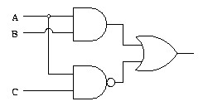
A. |  | A+c | B. | A+C+B
C. |  |  | D. | None
 | 13. If a 3-input NOR gate has eight input possibilities, how many of those possibilities will result in a HIGH output?
A. | 1 | B. | 2
C. | 7 | D. | 8

14. If a signal passing through a gate is inhibited by sending a LOW into one of the inputs, and the output is HIGH, the gate is a(n):
A. | AND | B. | NAND
C. | NOR | D. | OR

15. Which is correct grouping
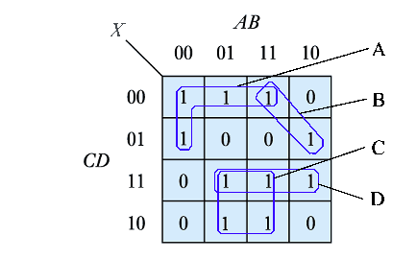
A. | A | B. | B
C. | C | D. | D

16. What logic function corresponds to the following circuit?
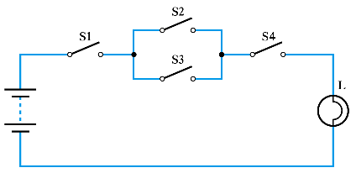
A. | L = (S1 OR S2) AND (S3 OR S4). | B. | L = S1 AND (S2 OR S3) AND S4
C. | L = S1 OR (S2 AND S3) OR S4 | D. | L = (S1 OR S2) AND (S3 OR S4).

17 number of switching functions of 3 variables is
A. | 8 | B. | 64
C. | 128 | D. | 256

18. The Boolean expression can be minimized as
A. |  | B.
C. |  | D.
19 the Boolean function AB+CD is to be realized using two input NAND gates. The minimum number of gates required is
A. | 2 | B. | 3
C. | 4 | D. | 5
2o The logic expression 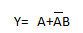is equal to

A. | A+B | B. | A+NOT B
C. | A-B | D. | NOT A + B

